DAY 2
TASK 2

Concept 1: Inspecting File Permissions Using ls -l and stat
Purpose: These commands display file permissions, ownership, file type, size, inode information, and timestamps.
Execution: I created a file using touch test.txt and inspected it using ls -l test.txt and stat test.txt.
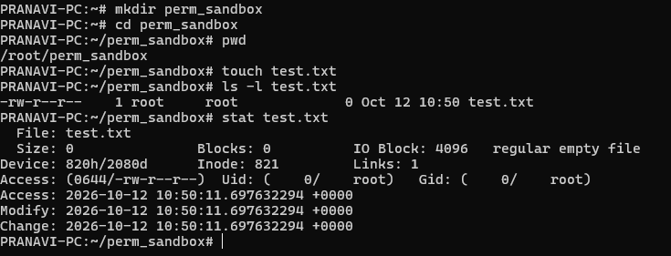
Symbolic mode uses letters to change permissions.
Symbol | Meaning
u | Owner
g | Group
o | Others
a | All users
+ | Add permissions
- | Remove permissions
= | Set exact permissions
Concept 2: Symbolic Permission Modification Using chmod
Purpose: The symbolic mode of chmod allows permissions to be added, removed, or explicitly assigned using user categories and permission operators.
Execution: I used chmod a+x test.txt to grant execute permission to everyone, chmod o-w test.txt to remove write permission for others, and chmod u=rw,g=,o= test.txt to restrict access to the owner.
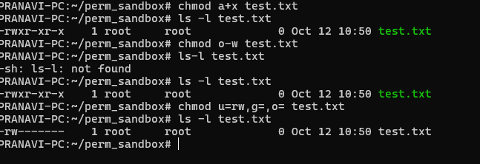
Concept 3: Octal Permission Modification Using chmod
Purpose: Numeric permission values provide a compact way to set read, write, and execute permissions for the owner, group, and others.
Execution: I used chmod 644 test.txt to set standard file permissions, chmod 755 . to set directory permissions, and chmod 700 test.txt to restrict access to the owner.
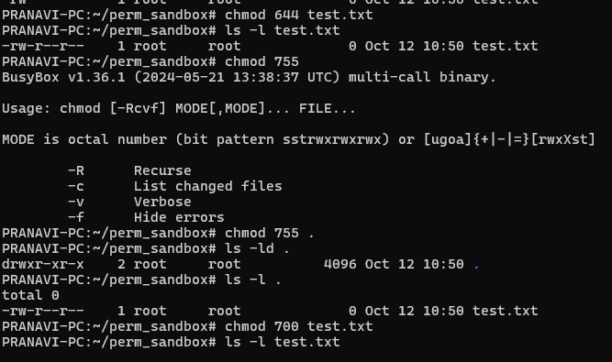

Concept 4: Recursive Permission Enforcement Using chmod -R
Purpose: The chmod -R command applies permission changes recursively to a directory and its contents.
Execution: I created a nested directory structure using mkdir -p a/b/c, created file.txt, and applied chmod -R 750 a/.
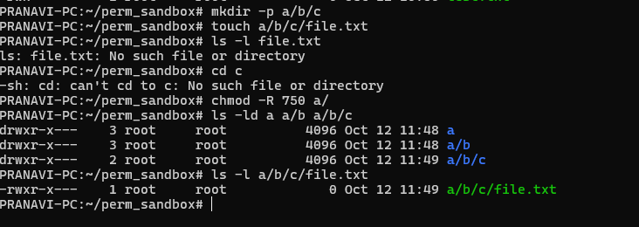

Concept 5: Ownership and Group Reassignment Using chown and chgrp
Purpose: The chown command changes file ownership, while chgrp changes the group associated with a file.
Execution: I used chown to assign the file owner, chown with owner and group arguments to modify both, and chgrp to change the file's group.
